AIM
To apply an Affine Transformation on an image, which changes the image using rotation, translation, scaling, and shearing while preserving straight lines.

INPUT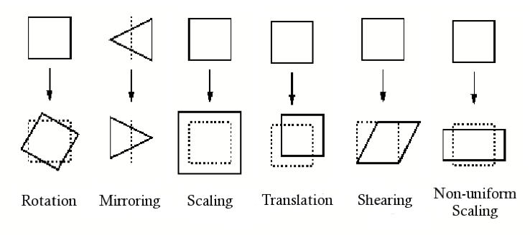

⭐ OUTPUT
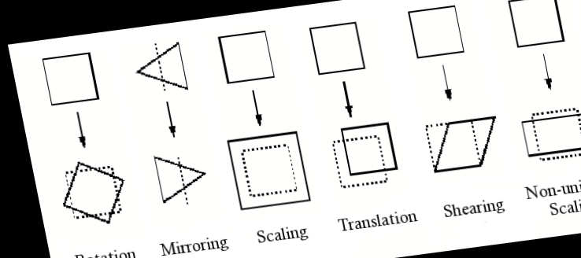

ALGORITHM
- Start the program.
- Import OpenCV and NumPy libraries.
- Load the input image.
- Select three coordinate points from the original image.
- Select three new points where these original points should move.
- Use cv2.getAffineTransform() to generate the affine matrix.
- Apply the affine transform using cv2.warpAffine().
- Display and save the output image.
- End the program.

⭐ RESULT
The transformed image appears rotated, sheared, or shifted based on the three selected points.
Straight lines in the image remain straight (property of affine transform).

